2014-Apr-26 Illyria Sheriffs Cup Brockman

Log

Tides, Charleston Harbor:

Tides Sa 12:28L 18:44H Sun 7:12H 13:18L

Forecasts:

Harbor : N5-10, becoming E, Tonight: 5-10, Su: S5kt,

Offshore: Saturday: NW 10-15Kt, E 5-10 late, Ses 3-4 Feet - > 1-2 Ft

Sunday: S 10kt , Seas 2 feet.

8:29 Conditions:

NX2: 2.2 TWS, 050 NE

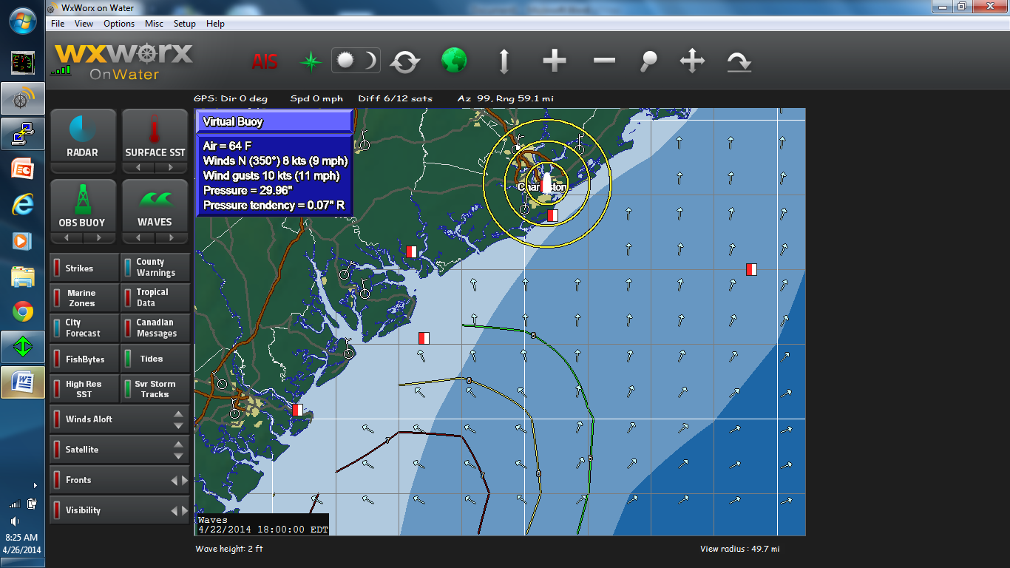

904 sa 5tws 015N

1049 11.3t 9.9aws

10.51 – start, late due to communication, ships clock was correct and gps time written on sticker at helm

1056 – first leg, 168M helm 000N 9.7TWS

WT,170,R,12.46,N,06.41,M,,\*30

$IIHDT,304,T\*3B

$GPWCV,-4.77,N,046,A\*5F

$GPXTE,A,A,,R,N,A\*03

$GPZDA,183031,26,04,2014,,\*47

$IIDBT,054.19,f,016.52,M,008.92,F\*2B

$GPGLL,3233.638,N,08011.049,W,183031,A,A\*54

$GPGSV,,,,,,,,,,,,,,,,,,,\*79

$IIHDM,312,M\*3C

$IIHDT,304,T\*3B

$IIMWD,115.02,T,122.32,M,12.73,N,06.55,M\*42

$IIVDR,319.72,T,327.02,M,2.70,N\*06

$IIVHW,304,T,312,M,06.89,N,12.76,K\*57

$IIVPW,-6.88,N,,\*2A

$IIVTG,308.41,T,315.71,M,9.56,N,,,N\*6B

$IIMWV,164,T,09.93,N,A\*25

$IIVWT,164,R,09.93,N,05.11,M,,\*31

$IIHDT,304,T\*3B

$GPWCV,,N,,N\*55

$GPXTE,A,A,,R,N,N\*0C

$GPZDA,183041,26,04,2014,,\*40

$IIDBT,054.16,f,016.51,M,008.92,F\*27

$GPGLL,3233.642,N,08011.054,W,183041,A,N\*5D

$GPGSV,,,,,,,,,,,,,,,,,,,\*79

$IIHDM,312,M\*3C

$IIHDT,305,T\*3A

$IIMWD,115.65,T,122.95,M,12.67,N,06.52,M\*4C

$IIVDR,321.37,T,328.67,M,2.82,N\*0D

$IIVHW,305,T,312,M,06.82,N,12.63,K\*59

$IIVPW,-6.73,N,,\*2E

$IIVTG,308.55,T

FINSH TIME REPORTED TO Rbowden707@gmail: 14:43:02, just after fearless ,just before EMO